3/17/2020

JAVA OS

An Operating System Simulation

Group details: Name – Harsh Agrawal , Roll No. – B005 , Email- harsh.agrawal03@nmims.edu.in

B.Tech |Computer engineering| Semester IV | AY 2019-20

Contents

**Introduction –** JavaOS is a simulation of an real Operating System with all the basic and essential functionalities . The user logs in and then a desktop is provided which provides various functions for user to perform. MyComputer opens up a UI with three disks and each disk has three folders and then this three folder opens up. Notepad opens up windows notepad. Terminal runs the provided command on the windows terminal and then the OutputStream is changed to this terminal and it displays all the text on this terminal. Browser opens up Microsoft Edge with [www.google.com](http://www.google.com) as its home page. About gives information about the developer. Run bar can be used to open up any of the above windows.

**Hardware requirements –**

Any Device(PC or Laptop), with the required software can be used for this project

**Software requirements** –

Processors: Intel Core™ i3 processor or higher

Disk space: 500 MB

Operating systems: Windows XP or later, macOS, and Linux

Java Version: 1.8.0_221 or above

**Block diagram of the system -**

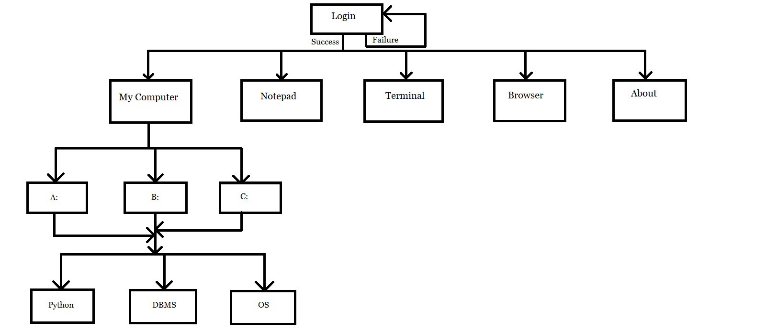

**List of functionalities being implemented –**

1. A text editor (Notepad)

2. Command Prompt / Terminal

3. Browser

4. My Computer (with virtual disk partition)

5. Run

6. About – Information about developer

7. Authentication

8. Music Player (It plays only in background during startup)

**Task Distribution done among all group members –**

All Tasks were done by me.

**Correlation of these components with OS concepts. –**

1. Authentication and Event Handling(i.e. Button Clicks) provides I/O Management
2. Virtual Disks and Folders provides Memory Management
3. Multiple Software can be run at the same time providing Process Management
4. Multiple Processes can be run at the same time providing Concurrency.

**Which Algorithms adopted from OS concepts studies? Why? Why not other alternatives if any? –**

1. FCFS for process scheduling as for this project process should be scheduled according to their arrival time.
2. Least Recently Used Algorithm for Page Replacement to store more used processes at the top and provide less page fault.
3. Directories and folders are created to simulate Memory Managment

**Flow chart and Code –**

1. FirstPage.java

package javaos;

import java.awt.event.KeyEvent;

import java.io.IOException;

import java.util.logging.Level;

import java.util.logging.Logger;

import javax.sound.sampled.LineUnavailableException;

import javax.sound.sampled.UnsupportedAudioFileException;

import javax.swing.JOptionPane;

public class FirstPage extends javax.swing.JFrame {

public FirstPage() {

initComponents();

}

@SuppressWarnings("unchecked")

private void initComponents() {

jPanel1 = new javax.swing.JPanel();

jButton1 = new javax.swing.JButton();

jTextField1 = new javax.swing.JTextField();

jLabel1 = new javax.swing.JLabel();

jLabel2 = new javax.swing.JLabel();

jPasswordField1 = new javax.swing.JPasswordField();

jTextField3 = new javax.swing.JTextField();

jLabel3 = new javax.swing.JLabel();

setDefaultCloseOperation(javax.swing.WindowConstants.EXIT_ON_CLOSE);

setBackground(new java.awt.Color(250, 250, 250));

jPanel1.setBackground(new java.awt.Color(153, 255, 255));

jButton1.setText("Login");

jButton1.addChangeListener(new javax.swing.event.ChangeListener() {

public void stateChanged(javax.swing.event.ChangeEvent evt) {

jButton1StateChanged(evt);

}

});

jButton1.addActionListener(new java.awt.event.ActionListener() {

public void actionPerformed(java.awt.event.ActionEvent evt) {

jButton1ActionPerformed(evt);

}

});

jLabel1.setText("Username");

jLabel2.setText("Password");

jPasswordField1.addKeyListener(new java.awt.event.KeyAdapter() {

public void keyPressed(java.awt.event.KeyEvent evt) {

jPasswordField1KeyPressed(evt);

}

});

jTextField3.setEditable(false);

jTextField3.setBackground(new java.awt.Color(255, 255, 255));

jTextField3.setFont(new java.awt.Font("Segoe UI", 3, 24)); // NOI18N

jTextField3.setHorizontalAlignment(javax.swing.JTextField.CENTER);

jTextField3.setText("-----Welcome to Java OS-----");

jTextField3.addActionListener(new java.awt.event.ActionListener() {

public void actionPerformed(java.awt.event.ActionEvent evt) {

jTextField3ActionPerformed(evt);

}

});

jLabel3.setForeground(new java.awt.Color(255, 0, 0));

javax.swing.GroupLayout jPanel1Layout = new javax.swing.GroupLayout(jPanel1);

jPanel1.setLayout(jPanel1Layout);

jPanel1Layout.setHorizontalGroup(

jPanel1Layout.createParallelGroup(javax.swing.GroupLayout.Alignment.LEADING)

.addComponent(jTextField3, javax.swing.GroupLayout.Alignment.TRAILING)

.addGroup(jPanel1Layout.createSequentialGroup()

.addGap(560, 560, 560)

.addGroup(jPanel1Layout.createParallelGroup(javax.swing.GroupLayout.Alignment.LEADING)

.addComponent(jLabel2, javax.swing.GroupLayout.PREFERRED_SIZE, 64, javax.swing.GroupLayout.PREFERRED_SIZE)

.addComponent(jLabel1, javax.swing.GroupLayout.PREFERRED_SIZE, 79, javax.swing.GroupLayout.PREFERRED_SIZE))

.addGap(22, 22, 22)

.addGroup(jPanel1Layout.createParallelGroup(javax.swing.GroupLayout.Alignment.LEADING, false)

.addComponent(jLabel3, javax.swing.GroupLayout.DEFAULT_SIZE, 202, Short.MAX_VALUE)

.addComponent(jTextField1, javax.swing.GroupLayout.DEFAULT_SIZE, 202, Short.MAX_VALUE)

.addComponent(jPasswordField1))

.addContainerGap(447, Short.MAX_VALUE))

.addGroup(javax.swing.GroupLayout.Alignment.TRAILING, jPanel1Layout.createSequentialGroup()

.addContainerGap(javax.swing.GroupLayout.DEFAULT_SIZE, Short.MAX_VALUE)

.addComponent(jButton1, javax.swing.GroupLayout.PREFERRED_SIZE, 89, javax.swing.GroupLayout.PREFERRED_SIZE)

.addGap(597, 597, 597))

);

jPanel1Layout.setVerticalGroup(

jPanel1Layout.createParallelGroup(javax.swing.GroupLayout.Alignment.LEADING)

.addGroup(javax.swing.GroupLayout.Alignment.TRAILING, jPanel1Layout.createSequentialGroup()

.addComponent(jTextField3, javax.swing.GroupLayout.PREFERRED_SIZE, 62, javax.swing.GroupLayout.PREFERRED_SIZE)

.addPreferredGap(javax.swing.LayoutStyle.ComponentPlacement.RELATED, 209, Short.MAX_VALUE)

.addGroup(jPanel1Layout.createParallelGroup(javax.swing.GroupLayout.Alignment.BASELINE)

.addComponent(jLabel1, javax.swing.GroupLayout.PREFERRED_SIZE, 30, javax.swing.GroupLayout.PREFERRED_SIZE)

.addComponent(jTextField1, javax.swing.GroupLayout.PREFERRED_SIZE, 30, javax.swing.GroupLayout.PREFERRED_SIZE))

.addGap(29, 29, 29)

.addGroup(jPanel1Layout.createParallelGroup(javax.swing.GroupLayout.Alignment.BASELINE)

.addComponent(jLabel2, javax.swing.GroupLayout.PREFERRED_SIZE, 27, javax.swing.GroupLayout.PREFERRED_SIZE)

.addComponent(jPasswordField1, javax.swing.GroupLayout.PREFERRED_SIZE, 31, javax.swing.GroupLayout.PREFERRED_SIZE))

.addPreferredGap(javax.swing.LayoutStyle.ComponentPlacement.RELATED)

.addComponent(jLabel3)

.addGap(46, 46, 46)

.addComponent(jButton1, javax.swing.GroupLayout.PREFERRED_SIZE, 36, javax.swing.GroupLayout.PREFERRED_SIZE)

.addGap(324, 324, 324))

);

javax.swing.GroupLayout layout = new javax.swing.GroupLayout(getContentPane());

getContentPane().setLayout(layout);

layout.setHorizontalGroup(

layout.createParallelGroup(javax.swing.GroupLayout.Alignment.LEADING)

.addComponent(jPanel1, javax.swing.GroupLayout.DEFAULT_SIZE, javax.swing.GroupLayout.DEFAULT_SIZE, Short.MAX_VALUE)

);

layout.setVerticalGroup(

layout.createParallelGroup(javax.swing.GroupLayout.Alignment.LEADING)

.addComponent(jPanel1, javax.swing.GroupLayout.DEFAULT_SIZE, javax.swing.GroupLayout.DEFAULT_SIZE, Short.MAX_VALUE)

);

pack();

}

private void jButton1ActionPerformed(java.awt.event.ActionEvent evt) {

try {

authentication();

} catch (UnsupportedAudioFileException | IOException | LineUnavailableException ex) {

Logger.getLogger(FirstPage.class.getName()).log(Level.SEVERE, null, ex);

}

}

private void authentication() throws UnsupportedAudioFileException, IOException, LineUnavailableException

{

String pass = jPasswordField1.getText().trim();

String user = jTextField1.getText().trim();

if(user.equals("harsh")&&pass.equals("password") )

{

JOptionPane.showMessageDialog(this, "Succesfully Logged In!!");

Music.music("Music\\\\StartSound.wav");

MainPage ob = new MainPage();

ob.setVisible(true);

dispose();

}

else

{

if(user.isEmpty()||pass.isEmpty())

{

jLabel3.setVisible(true);

jLabel3.setText("Fields can't be empty!!!");

}

else{

jLabel3.setVisible(true);

jLabel3.setText("Invalid Details!!!");

jPasswordField1.setText("");

}

}

}

private void jPasswordField1KeyPressed(java.awt.event.KeyEvent evt) {

if(evt.getKeyCode()==KeyEvent.VK_ENTER)

{

try {

authentication();

} catch (UnsupportedAudioFileException | IOException | LineUnavailableException ex) {

Logger.getLogger(FirstPage.class.getName()).log(Level.SEVERE, null, ex);

}

}

}

public static void main(String args[]) {

try {

for (javax.swing.UIManager.LookAndFeelInfo info : javax.swing.UIManager.getInstalledLookAndFeels()) {

if ("Nimbus".equals(info.getName())) {

javax.swing.UIManager.setLookAndFeel(info.getClassName());

break;

}

}

} catch (ClassNotFoundException | InstantiationException | IllegalAccessException | javax.swing.UnsupportedLookAndFeelException ex) {

java.util.logging.Logger.getLogger(FirstPage.class.getName()).log(java.util.logging.Level.SEVERE, null, ex);

}

java.awt.EventQueue.invokeLater(() -> {

new FirstPage().setVisible(true);

});

}

private javax.swing.JButton jButton1;

private javax.swing.JLabel jLabel1;

private javax.swing.JLabel jLabel2;

private javax.swing.JLabel jLabel3;

private javax.swing.JPanel jPanel1;

private javax.swing.JPasswordField jPasswordField1;

private javax.swing.JTextField jTextField1;

private javax.swing.JTextField jTextField3;

}

1. MainPage.java

package javaos;

import java.io.IOException;

import java.util.logging.Level;

import java.util.logging.Logger;

import javax.swing.JOptionPane;

public class MainPage extends javax.swing.JFrame {

public MainPage() {

initComponents();

}

@SuppressWarnings("unchecked")

private void initComponents() {

jPanel1 = new javax.swing.JPanel();

jLabel5 = new javax.swing.JLabel();

jLabel4 = new javax.swing.JLabel();

jLabel3 = new javax.swing.JLabel();

jLabel2 = new javax.swing.JLabel();

jButton3 = new javax.swing.JButton();

jButton4 = new javax.swing.JButton();

jButton2 = new javax.swing.JButton();

jButton1 = new javax.swing.JButton();

jButton5 = new javax.swing.JButton();

jButton6 = new javax.swing.JButton();

jLabel1 = new javax.swing.JLabel();

jRunField = new javax.swing.JTextField();

setDefaultCloseOperation(javax.swing.WindowConstants.EXIT_ON_CLOSE);

setBackground(new java.awt.Color(102, 10, 153));

jPanel1.setBackground(new java.awt.Color(153, 255, 255));

jPanel1.setCursor(new java.awt.Cursor(java.awt.Cursor.DEFAULT_CURSOR));

jLabel5.setHorizontalAlignment(javax.swing.SwingConstants.CENTER);

jLabel5.setText("About");

jLabel4.setHorizontalAlignment(javax.swing.SwingConstants.CENTER);

jLabel4.setText("Terminal");

jLabel3.setHorizontalAlignment(javax.swing.SwingConstants.CENTER);

jLabel3.setText("Notepad");

jLabel2.setHorizontalAlignment(javax.swing.SwingConstants.CENTER);

jLabel2.setText("My Computer");

jButton3.setIcon(new javax.swing.ImageIcon(getClass().getResource("/resource/untitled.png"))); // NOI18N

jButton3.setText("jButton3");

jButton3.addActionListener(new java.awt.event.ActionListener() {

public void actionPerformed(java.awt.event.ActionEvent evt) {

jButton3ActionPerformed(evt);

}

});

jButton4.setIcon(new javax.swing.ImageIcon(getClass().getResource("/resource/about.png"))); // NOI18N

jButton4.addActionListener(new java.awt.event.ActionListener() {

public void actionPerformed(java.awt.event.ActionEvent evt) {

jButton4ActionPerformed(evt);

}

});

jButton2.setBackground(new java.awt.Color(153, 255, 255));

jButton2.setForeground(new java.awt.Color(153, 255, 255));

jButton2.setIcon(new javax.swing.ImageIcon(getClass().getResource("/resource/notepad.png"))); // NOI18N

jButton2.setBorder(null);

jButton2.setBorderPainted(false);

jButton2.addActionListener(new java.awt.event.ActionListener() {

public void actionPerformed(java.awt.event.ActionEvent evt) {

jButton2ActionPerformed(evt);

}

});

jButton1.setBackground(new java.awt.Color(153, 255, 255));

jButton1.setForeground(new java.awt.Color(153, 255, 255));

jButton1.setIcon(new javax.swing.ImageIcon(getClass().getResource("/resource/mycomputer.png"))); // NOI18N

jButton1.setBorder(null);

jButton1.setBorderPainted(false);

jButton1.addActionListener(new java.awt.event.ActionListener() {

public void actionPerformed(java.awt.event.ActionEvent evt) {

jButton1ActionPerformed(evt);

}

});

jButton5.setText("Run");

jButton5.addActionListener(new java.awt.event.ActionListener() {

public void actionPerformed(java.awt.event.ActionEvent evt) {

jButton5ActionPerformed(evt);

}

});

jButton6.setBackground(new java.awt.Color(153, 255, 255));

jButton6.setIcon(new javax.swing.ImageIcon(getClass().getResource("/resource/browser.png"))); // NOI18N

jButton6.addActionListener(new java.awt.event.ActionListener() {

public void actionPerformed(java.awt.event.ActionEvent evt) {

jButton6ActionPerformed(evt);

}

});

jLabel1.setHorizontalAlignment(javax.swing.SwingConstants.CENTER);

jLabel1.setText("Browser");

javax.swing.GroupLayout jPanel1Layout = new javax.swing.GroupLayout(jPanel1);

jPanel1.setLayout(jPanel1Layout);

jPanel1Layout.setHorizontalGroup(

jPanel1Layout.createParallelGroup(javax.swing.GroupLayout.Alignment.LEADING)

.addGroup(jPanel1Layout.createSequentialGroup()

.addGroup(jPanel1Layout.createParallelGroup(javax.swing.GroupLayout.Alignment.LEADING)

.addGroup(jPanel1Layout.createSequentialGroup()

.addGroup(jPanel1Layout.createParallelGroup(javax.swing.GroupLayout.Alignment.LEADING)

.addGroup(jPanel1Layout.createSequentialGroup()

.addGap(40, 40, 40)

.addComponent(jLabel2, javax.swing.GroupLayout.PREFERRED_SIZE, 231, javax.swing.GroupLayout.PREFERRED_SIZE))

.addGroup(jPanel1Layout.createSequentialGroup()

.addGap(62, 62, 62)

.addComponent(jButton1, javax.swing.GroupLayout.PREFERRED_SIZE, 171, javax.swing.GroupLayout.PREFERRED_SIZE)))

.addGroup(jPanel1Layout.createParallelGroup(javax.swing.GroupLayout.Alignment.LEADING)

.addGroup(jPanel1Layout.createSequentialGroup()

.addGap(47, 47, 47)

.addComponent(jLabel3, javax.swing.GroupLayout.PREFERRED_SIZE, 224, javax.swing.GroupLayout.PREFERRED_SIZE))

.addGroup(jPanel1Layout.createSequentialGroup()

.addGap(69, 69, 69)

.addComponent(jButton2, javax.swing.GroupLayout.PREFERRED_SIZE, 187, javax.swing.GroupLayout.PREFERRED_SIZE))))

.addGroup(jPanel1Layout.createSequentialGroup()

.addGap(76, 76, 76)

.addGroup(jPanel1Layout.createParallelGroup(javax.swing.GroupLayout.Alignment.LEADING)

.addComponent(jButton6, javax.swing.GroupLayout.PREFERRED_SIZE, 149, javax.swing.GroupLayout.PREFERRED_SIZE)

.addComponent(jLabel1, javax.swing.GroupLayout.PREFERRED_SIZE, 157, javax.swing.GroupLayout.PREFERRED_SIZE))))

.addGroup(jPanel1Layout.createParallelGroup(javax.swing.GroupLayout.Alignment.LEADING)

.addGroup(jPanel1Layout.createSequentialGroup()

.addGap(50, 50, 50)

.addGroup(jPanel1Layout.createParallelGroup(javax.swing.GroupLayout.Alignment.LEADING, false)

.addComponent(jButton3, javax.swing.GroupLayout.PREFERRED_SIZE, 209, javax.swing.GroupLayout.PREFERRED_SIZE)

.addComponent(jLabel4, javax.swing.GroupLayout.DEFAULT_SIZE, javax.swing.GroupLayout.DEFAULT_SIZE, Short.MAX_VALUE))

.addGap(82, 82, 82)

.addGroup(jPanel1Layout.createParallelGroup(javax.swing.GroupLayout.Alignment.LEADING, false)

.addComponent(jButton4, javax.swing.GroupLayout.Alignment.TRAILING, javax.swing.GroupLayout.PREFERRED_SIZE, 153, javax.swing.GroupLayout.PREFERRED_SIZE)

.addComponent(jLabel5, javax.swing.GroupLayout.DEFAULT_SIZE, javax.swing.GroupLayout.DEFAULT_SIZE, Short.MAX_VALUE))

.addContainerGap(211, Short.MAX_VALUE))

.addGroup(jPanel1Layout.createSequentialGroup()

.addPreferredGap(javax.swing.LayoutStyle.ComponentPlacement.RELATED, javax.swing.GroupLayout.DEFAULT_SIZE, Short.MAX_VALUE)

.addComponent(jButton5)

.addPreferredGap(javax.swing.LayoutStyle.ComponentPlacement.RELATED)

.addComponent(jRunField, javax.swing.GroupLayout.PREFERRED_SIZE, 182, javax.swing.GroupLayout.PREFERRED_SIZE)

.addGap(91, 91, 91))))

);

jPanel1Layout.setVerticalGroup(

jPanel1Layout.createParallelGroup(javax.swing.GroupLayout.Alignment.LEADING)

.addGroup(jPanel1Layout.createSequentialGroup()

.addGap(97, 97, 97)

.addGroup(jPanel1Layout.createParallelGroup(javax.swing.GroupLayout.Alignment.LEADING)

.addComponent(jButton1, javax.swing.GroupLayout.PREFERRED_SIZE, 168, javax.swing.GroupLayout.PREFERRED_SIZE)

.addComponent(jButton3, javax.swing.GroupLayout.PREFERRED_SIZE, 172, javax.swing.GroupLayout.PREFERRED_SIZE)

.addComponent(jButton4, javax.swing.GroupLayout.Alignment.TRAILING)

.addComponent(jButton2, javax.swing.GroupLayout.Alignment.TRAILING, javax.swing.GroupLayout.PREFERRED_SIZE, 162, javax.swing.GroupLayout.PREFERRED_SIZE))

.addPreferredGap(javax.swing.LayoutStyle.ComponentPlacement.RELATED)

.addGroup(jPanel1Layout.createParallelGroup(javax.swing.GroupLayout.Alignment.LEADING)

.addComponent(jLabel2)

.addComponent(jLabel3)

.addGroup(jPanel1Layout.createParallelGroup(javax.swing.GroupLayout.Alignment.BASELINE)

.addComponent(jLabel5)

.addComponent(jLabel4)))

.addGroup(jPanel1Layout.createParallelGroup(javax.swing.GroupLayout.Alignment.LEADING)

.addGroup(jPanel1Layout.createSequentialGroup()

.addGap(181, 181, 181)

.addGroup(jPanel1Layout.createParallelGroup(javax.swing.GroupLayout.Alignment.BASELINE)

.addComponent(jButton5)

.addComponent(jRunField, javax.swing.GroupLayout.PREFERRED_SIZE, javax.swing.GroupLayout.DEFAULT_SIZE, javax.swing.GroupLayout.PREFERRED_SIZE)))

.addGroup(jPanel1Layout.createSequentialGroup()

.addGap(61, 61, 61)

.addComponent(jButton6)

.addPreferredGap(javax.swing.LayoutStyle.ComponentPlacement.RELATED)

.addComponent(jLabel1)))

.addContainerGap(157, Short.MAX_VALUE))

);

javax.swing.GroupLayout layout = new javax.swing.GroupLayout(getContentPane());

getContentPane().setLayout(layout);

layout.setHorizontalGroup(

layout.createParallelGroup(javax.swing.GroupLayout.Alignment.LEADING)

.addComponent(jPanel1, javax.swing.GroupLayout.DEFAULT_SIZE, javax.swing.GroupLayout.DEFAULT_SIZE, Short.MAX_VALUE)

);

layout.setVerticalGroup(

layout.createParallelGroup(javax.swing.GroupLayout.Alignment.LEADING)

.addComponent(jPanel1, javax.swing.GroupLayout.DEFAULT_SIZE, javax.swing.GroupLayout.DEFAULT_SIZE, Short.MAX_VALUE)

);

pack();

}

private void jButton4ActionPerformed(java.awt.event.ActionEvent evt) {

AboutPage ap =new AboutPage();

ap.setVisible(true);

}

private void jButton5ActionPerformed(java.awt.event.ActionEvent evt) {

String s =jRunField.getText().toUpperCase();

jRunField.setText("");

switch (s) {

case "NOTEPAD":

jButton2ActionPerformed(evt);

break;

case "TERMINAL":

jButton3ActionPerformed(evt);

break;

case "MYPC":

jButton1ActionPerformed(evt);

break;

case "ABOUT":

jButton4ActionPerformed(evt);

break;

case "BROWSER":

jButton6ActionPerformed(evt);

break;

default:

JOptionPane.showMessageDialog(this, "Inavlid Command!!");

break;

}

}

private void jButton2ActionPerformed(java.awt.event.ActionEvent evt) {

Console note =new Console();

Console.runNotepad();

}

private void jButton1ActionPerformed(java.awt.event.ActionEvent evt) {

MyComputer mc = new MyComputer();

mc.setVisible(true);

}

private void jButton3ActionPerformed(java.awt.event.ActionEvent evt) {

Terminal term = new Terminal();

term.setVisible(true);

}

private void jButton6ActionPerformed(java.awt.event.ActionEvent evt) {

try {

Runtime.getRuntime().exec("cmd.exe /C start microsoft-edge:http://www.google.com");

} catch (IOException ex) {

Logger.getLogger(MainPage.class.getName()).log(Level.SEVERE, null, ex);

}

}

public static void main(String args[]) {

try {

for (javax.swing.UIManager.LookAndFeelInfo info : javax.swing.UIManager.getInstalledLookAndFeels()) {

if ("Nimbus".equals(info.getName())) {

javax.swing.UIManager.setLookAndFeel(info.getClassName());

break;

}

}

} catch (ClassNotFoundException | InstantiationException | IllegalAccessException | javax.swing.UnsupportedLookAndFeelException ex) {

java.util.logging.Logger.getLogger(MainPage.class.getName()).log(java.util.logging.Level.SEVERE, null, ex);

}

java.awt.EventQueue.invokeLater(() -> {

new MainPage().setVisible(true);

});

}

private javax.swing.JButton jButton1;

private javax.swing.JButton jButton2;

private javax.swing.JButton jButton3;

private javax.swing.JButton jButton4;

private javax.swing.JButton jButton5;

private javax.swing.JButton jButton6;

private javax.swing.JLabel jLabel1;

private javax.swing.JLabel jLabel2;

private javax.swing.JLabel jLabel3;

private javax.swing.JLabel jLabel4;

private javax.swing.JLabel jLabel5;

private javax.swing.JPanel jPanel1;

private javax.swing.JTextField jRunField;

}

1. MyComputer.java

package javaos;

import static javaos.AboutPage.priority;

public class MyComputer extends javax.swing.JFrame {

public static int priority = 10;

public MyComputer() {

initComponents();

}

@SuppressWarnings("unchecked")

private void initComponents() {

jPanel1 = new javax.swing.JPanel();

jButton1 = new javax.swing.JButton();

jButton2 = new javax.swing.JButton();

jButton3 = new javax.swing.JButton();

jLabel1 = new javax.swing.JLabel();

jLabel2 = new javax.swing.JLabel();

jLabel3 = new javax.swing.JLabel();

setDefaultCloseOperation(javax.swing.WindowConstants.DISPOSE_ON_CLOSE);

jPanel1.setBackground(new java.awt.Color(153, 255, 255));

jButton1.setIcon(new javax.swing.ImageIcon(getClass().getResource("/javaos/drive.png"))); // NOI18N

jButton1.addActionListener(new java.awt.event.ActionListener() {

public void actionPerformed(java.awt.event.ActionEvent evt) {

jButton1ActionPerformed(evt);

}

});

jButton2.setIcon(new javax.swing.ImageIcon(getClass().getResource("/javaos/drive.png"))); // NOI18N

jButton2.addActionListener(new java.awt.event.ActionListener() {

public void actionPerformed(java.awt.event.ActionEvent evt) {

jButton2ActionPerformed(evt);

}

});

jButton3.setIcon(new javax.swing.ImageIcon(getClass().getResource("/javaos/drive.png"))); // NOI18N

jButton3.addActionListener(new java.awt.event.ActionListener() {

public void actionPerformed(java.awt.event.ActionEvent evt) {

jButton3ActionPerformed(evt);

}

});

jLabel1.setText("New Volume (B:)");

jLabel2.setText("Windows (C:)");

jLabel3.setText("New Volume (A:)");

javax.swing.GroupLayout jPanel1Layout = new javax.swing.GroupLayout(jPanel1);

jPanel1.setLayout(jPanel1Layout);

jPanel1Layout.setHorizontalGroup(

jPanel1Layout.createParallelGroup(javax.swing.GroupLayout.Alignment.LEADING)

.addGroup(jPanel1Layout.createSequentialGroup()

.addGap(198, 198, 198)

.addGroup(jPanel1Layout.createParallelGroup(javax.swing.GroupLayout.Alignment.LEADING, false)

.addGroup(jPanel1Layout.createSequentialGroup()

.addGap(10, 10, 10)

.addComponent(jLabel3, javax.swing.GroupLayout.DEFAULT_SIZE, javax.swing.GroupLayout.DEFAULT_SIZE, Short.MAX_VALUE))

.addComponent(jButton1, javax.swing.GroupLayout.PREFERRED_SIZE, 125, javax.swing.GroupLayout.PREFERRED_SIZE))

.addGap(79, 79, 79)

.addGroup(jPanel1Layout.createParallelGroup(javax.swing.GroupLayout.Alignment.TRAILING)

.addComponent(jLabel1, javax.swing.GroupLayout.PREFERRED_SIZE, 117, javax.swing.GroupLayout.PREFERRED_SIZE)

.addComponent(jButton2, javax.swing.GroupLayout.PREFERRED_SIZE, 125, javax.swing.GroupLayout.PREFERRED_SIZE))

.addGap(80, 80, 80)

.addGroup(jPanel1Layout.createParallelGroup(javax.swing.GroupLayout.Alignment.LEADING, false)

.addGroup(jPanel1Layout.createSequentialGroup()

.addGap(10, 10, 10)

.addComponent(jLabel2, javax.swing.GroupLayout.DEFAULT_SIZE, javax.swing.GroupLayout.DEFAULT_SIZE, Short.MAX_VALUE))

.addComponent(jButton3, javax.swing.GroupLayout.PREFERRED_SIZE, 125, javax.swing.GroupLayout.PREFERRED_SIZE))

.addContainerGap(371, Short.MAX_VALUE))

);

jPanel1Layout.setVerticalGroup(

jPanel1Layout.createParallelGroup(javax.swing.GroupLayout.Alignment.LEADING)

.addGroup(jPanel1Layout.createSequentialGroup()

.addGap(78, 78, 78)

.addGroup(jPanel1Layout.createParallelGroup(javax.swing.GroupLayout.Alignment.LEADING, false)

.addComponent(jButton2, javax.swing.GroupLayout.DEFAULT_SIZE, javax.swing.GroupLayout.DEFAULT_SIZE, Short.MAX_VALUE)

.addComponent(jButton3, javax.swing.GroupLayout.DEFAULT_SIZE, javax.swing.GroupLayout.DEFAULT_SIZE, Short.MAX_VALUE)

.addComponent(jButton1, javax.swing.GroupLayout.DEFAULT_SIZE, javax.swing.GroupLayout.DEFAULT_SIZE, Short.MAX_VALUE))

.addPreferredGap(javax.swing.LayoutStyle.ComponentPlacement.RELATED)

.addGroup(jPanel1Layout.createParallelGroup(javax.swing.GroupLayout.Alignment.BASELINE)

.addComponent(jLabel1)

.addComponent(jLabel2)

.addComponent(jLabel3))

.addContainerGap(520, Short.MAX_VALUE))

);

javax.swing.GroupLayout layout = new javax.swing.GroupLayout(getContentPane());

getContentPane().setLayout(layout);

layout.setHorizontalGroup(

layout.createParallelGroup(javax.swing.GroupLayout.Alignment.LEADING)

.addComponent(jPanel1, javax.swing.GroupLayout.Alignment.TRAILING, javax.swing.GroupLayout.DEFAULT_SIZE, javax.swing.GroupLayout.DEFAULT_SIZE, Short.MAX_VALUE)

);

layout.setVerticalGroup(

layout.createParallelGroup(javax.swing.GroupLayout.Alignment.LEADING)

.addComponent(jPanel1, javax.swing.GroupLayout.Alignment.TRAILING, javax.swing.GroupLayout.DEFAULT_SIZE, javax.swing.GroupLayout.DEFAULT_SIZE, Short.MAX_VALUE)

);

pack();

}

private void jButton1ActionPerformed(java.awt.event.ActionEvent evt) {

DriveMenus dm =new DriveMenus();

dm.setVisible(true);

}

private void jButton2ActionPerformed(java.awt.event.ActionEvent evt) {

DriveMenus dm =new DriveMenus();

dm.setVisible(true);

}

private void jButton3ActionPerformed(java.awt.event.ActionEvent evt) {

DriveMenus dm =new DriveMenus();

dm.setVisible(true);

}

public static void main(String args[]) {

try {

for (javax.swing.UIManager.LookAndFeelInfo info : javax.swing.UIManager.getInstalledLookAndFeels()) {

if ("Nimbus".equals(info.getName())) {

javax.swing.UIManager.setLookAndFeel(info.getClassName());

break;

}

}

} catch (ClassNotFoundException ex) {

java.util.logging.Logger.getLogger(MyComputer.class.getName()).log(java.util.logging.Level.SEVERE, null, ex);

} catch (InstantiationException ex) {

java.util.logging.Logger.getLogger(MyComputer.class.getName()).log(java.util.logging.Level.SEVERE, null, ex);

} catch (IllegalAccessException ex) {

java.util.logging.Logger.getLogger(MyComputer.class.getName()).log(java.util.logging.Level.SEVERE, null, ex);

} catch (javax.swing.UnsupportedLookAndFeelException ex) {

java.util.logging.Logger.getLogger(MyComputer.class.getName()).log(java.util.logging.Level.SEVERE, null, ex);

}

java.awt.EventQueue.invokeLater(new Runnable() {

public void run() {

MyComputer frame = new MyComputer();

if( ProcessScheduler.priorityCheck(priority))

frame.setVisible(true);

else

System.out.println("Memory Full");

}

});

}

private javax.swing.JButton jButton1;

private javax.swing.JButton jButton2;

private javax.swing.JButton jButton3;

private javax.swing.JLabel jLabel1;

private javax.swing.JLabel jLabel2;

private javax.swing.JLabel jLabel3;

private javax.swing.JPanel jPanel1;

}

1. DriveMenus.java

package javaos;

public class DriveMenus extends javax.swing.JFrame {

public DriveMenus() {

initComponents();

}

@SuppressWarnings("unchecked")

private void initComponents() {

jPanel1 = new javax.swing.JPanel();

jButton1 = new javax.swing.JButton();

jButton2 = new javax.swing.JButton();

jButton3 = new javax.swing.JButton();

jLabel1 = new javax.swing.JLabel();

jLabel2 = new javax.swing.JLabel();

jLabel3 = new javax.swing.JLabel();

setDefaultCloseOperation(javax.swing.WindowConstants.DISPOSE_ON_CLOSE);

jPanel1.setBackground(new java.awt.Color(153, 255, 255));

jButton1.setIcon(new javax.swing.ImageIcon(getClass().getResource("/javaos/foldericon.png"))); // NOI18N

jButton1.addActionListener(new java.awt.event.ActionListener() {

public void actionPerformed(java.awt.event.ActionEvent evt) {

jButton1ActionPerformed(evt);

}

});

jButton2.setIcon(new javax.swing.ImageIcon(getClass().getResource("/javaos/foldericon.png"))); // NOI18N

jButton2.addActionListener(new java.awt.event.ActionListener() {

public void actionPerformed(java.awt.event.ActionEvent evt) {

jButton2ActionPerformed(evt);

}

});

jButton3.setIcon(new javax.swing.ImageIcon(getClass().getResource("/javaos/foldericon.png"))); // NOI18N

jButton3.addActionListener(new java.awt.event.ActionListener() {

public void actionPerformed(java.awt.event.ActionEvent evt) {

jButton3ActionPerformed(evt);

}

});

jLabel1.setHorizontalAlignment(javax.swing.SwingConstants.CENTER);

jLabel1.setText("OS");

jLabel2.setHorizontalAlignment(javax.swing.SwingConstants.CENTER);

jLabel2.setText("Python");

jLabel3.setHorizontalAlignment(javax.swing.SwingConstants.CENTER);

jLabel3.setText("DBMS");

javax.swing.GroupLayout jPanel1Layout = new javax.swing.GroupLayout(jPanel1);

jPanel1.setLayout(jPanel1Layout);

jPanel1Layout.setHorizontalGroup(

jPanel1Layout.createParallelGroup(javax.swing.GroupLayout.Alignment.LEADING)

.addGroup(jPanel1Layout.createSequentialGroup()

.addGap(223, 223, 223)

.addGroup(jPanel1Layout.createParallelGroup(javax.swing.GroupLayout.Alignment.LEADING, false)

.addComponent(jLabel1, javax.swing.GroupLayout.DEFAULT_SIZE, 126, Short.MAX_VALUE)

.addComponent(jButton1, javax.swing.GroupLayout.PREFERRED_SIZE, 0, Short.MAX_VALUE))

.addGap(81, 81, 81)

.addGroup(jPanel1Layout.createParallelGroup(javax.swing.GroupLayout.Alignment.LEADING, false)

.addComponent(jButton2, javax.swing.GroupLayout.PREFERRED_SIZE, 126, javax.swing.GroupLayout.PREFERRED_SIZE)

.addComponent(jLabel2, javax.swing.GroupLayout.DEFAULT_SIZE, javax.swing.GroupLayout.DEFAULT_SIZE, Short.MAX_VALUE))

.addGap(29, 29, 29)

.addGroup(jPanel1Layout.createParallelGroup(javax.swing.GroupLayout.Alignment.LEADING)

.addGroup(jPanel1Layout.createSequentialGroup()

.addGap(59, 59, 59)

.addComponent(jButton3, javax.swing.GroupLayout.PREFERRED_SIZE, 126, javax.swing.GroupLayout.PREFERRED_SIZE))

.addGroup(javax.swing.GroupLayout.Alignment.TRAILING, jPanel1Layout.createSequentialGroup()

.addGap(61, 61, 61)

.addComponent(jLabel3, javax.swing.GroupLayout.PREFERRED_SIZE, 124, javax.swing.GroupLayout.PREFERRED_SIZE)))

.addContainerGap(382, Short.MAX_VALUE))

);

jPanel1Layout.setVerticalGroup(

jPanel1Layout.createParallelGroup(javax.swing.GroupLayout.Alignment.LEADING)

.addGroup(jPanel1Layout.createSequentialGroup()

.addGap(114, 114, 114)

.addGroup(jPanel1Layout.createParallelGroup(javax.swing.GroupLayout.Alignment.LEADING, false)

.addComponent(jButton3, javax.swing.GroupLayout.DEFAULT_SIZE, javax.swing.GroupLayout.DEFAULT_SIZE, Short.MAX_VALUE)

.addComponent(jButton1, javax.swing.GroupLayout.DEFAULT_SIZE, javax.swing.GroupLayout.DEFAULT_SIZE, Short.MAX_VALUE)

.addComponent(jButton2, javax.swing.GroupLayout.DEFAULT_SIZE, javax.swing.GroupLayout.DEFAULT_SIZE, Short.MAX_VALUE))

.addPreferredGap(javax.swing.LayoutStyle.ComponentPlacement.RELATED)

.addGroup(jPanel1Layout.createParallelGroup(javax.swing.GroupLayout.Alignment.LEADING)

.addComponent(jLabel3)

.addGroup(jPanel1Layout.createParallelGroup(javax.swing.GroupLayout.Alignment.BASELINE)

.addComponent(jLabel2)

.addComponent(jLabel1)))

.addContainerGap(491, Short.MAX_VALUE))

);

javax.swing.GroupLayout layout = new javax.swing.GroupLayout(getContentPane());

getContentPane().setLayout(layout);

layout.setHorizontalGroup(

layout.createParallelGroup(javax.swing.GroupLayout.Alignment.LEADING)

.addComponent(jPanel1, javax.swing.GroupLayout.Alignment.TRAILING, javax.swing.GroupLayout.DEFAULT_SIZE, javax.swing.GroupLayout.DEFAULT_SIZE, Short.MAX_VALUE)

);

layout.setVerticalGroup(

layout.createParallelGroup(javax.swing.GroupLayout.Alignment.LEADING)

.addComponent(jPanel1, javax.swing.GroupLayout.DEFAULT_SIZE, javax.swing.GroupLayout.DEFAULT_SIZE, Short.MAX_VALUE)

);

pack();

}

private void jButton1ActionPerformed(java.awt.event.ActionEvent evt) {

Console.runFolderOS();

}

private void jButton2ActionPerformed(java.awt.event.ActionEvent evt) {

Console.runFolderPython();

}

private void jButton3ActionPerformed(java.awt.event.ActionEvent evt) {

Console.runFolderDBMS();

}

public static void main(String args[]) {

java.awt.EventQueue.invokeLater(() -> {

new DriveMenus().setVisible(true);

});

}

private javax.swing.JButton jButton1;

private javax.swing.JButton jButton2;

private javax.swing.JButton jButton3;

private javax.swing.JLabel jLabel1;

private javax.swing.JLabel jLabel2;

private javax.swing.JLabel jLabel3;

private javax.swing.JPanel jPanel1;

}

1. Console.java

package javaos;

import java.io.IOException;

import java.awt.Desktop;

import java.io.File;

public class Console {

public static int priority = 7;

static Runtime rs =Runtime.getRuntime();

static Desktop desktop = Desktop.getDesktop();

static File folderToOpen;

static void runNotepad() {

try{

rs.exec("notepad");

}

catch(IOException e)

{

System.out.println(e);

}

}

static void runFolderOS() {

try {

folderToOpen = new File("C:\\Users\\harsh\\OneDrive\\Desktop\\OS");

desktop.open(folderToOpen);

} catch (IOException e) {

System.out.println(e);

}

}

static void runFolderPython() {

try{

folderToOpen = new File("C:\\Users\\harsh\\OneDrive\\Desktop\\Python");

desktop.open(folderToOpen);

}

catch(IOException e)

{

System.out.println(e);

}

}

static void runFolderDBMS() {

try{

folderToOpen = new File("C:\\Users\\harsh\\OneDrive\\Desktop\\DBMS");

desktop.open(folderToOpen);

}

catch(IOException e)

{

System.out.println(e);

}

}

}

1. Terminal.java

package javaos;

import java.awt.Color;

import java.awt.event.KeyEvent;

import java.io.IOException;

import java.io.PrintStream;

import java.io.PrintWriter;

import java.util.logging.Level;

import java.util.logging.Logger;

public class Terminal extends javax.swing.JFrame {

public static int priority = 8;

public Terminal() {

initComponents();

}

@SuppressWarnings("unchecked")

private void initComponents() {

jPanel1 = new javax.swing.JPanel();

jTextField1 = new javax.swing.JTextField();

jPanel2 = new javax.swing.JPanel();

jScrollPane1 = new javax.swing.JScrollPane();

jTextArea2 = new javax.swing.JTextArea();

javax.swing.GroupLayout jPanel1Layout = new javax.swing.GroupLayout(jPanel1);

jPanel1.setLayout(jPanel1Layout);

jPanel1Layout.setHorizontalGroup(

jPanel1Layout.createParallelGroup(javax.swing.GroupLayout.Alignment.LEADING)

.addGap(0, 100, Short.MAX_VALUE)

);

jPanel1Layout.setVerticalGroup(

jPanel1Layout.createParallelGroup(javax.swing.GroupLayout.Alignment.LEADING)

.addGap(0, 100, Short.MAX_VALUE)

);

jTextField1.setText("jTextField1");

setDefaultCloseOperation(javax.swing.WindowConstants.DISPOSE_ON_CLOSE);

setTitle("Command Prompt");

setResizable(false);

jPanel2.setBackground(new java.awt.Color(255, 255, 255));

jTextArea2.setBackground(new java.awt.Color(0, 0, 0));

jTextArea2.setColumns(20);

jTextArea2.setForeground(new java.awt.Color(255, 255, 255));

jTextArea2.setRows(5);

jTextArea2.addKeyListener(new java.awt.event.KeyAdapter() {

public void keyPressed(java.awt.event.KeyEvent evt) {

jTextArea2KeyPressed(evt);

}

});

jScrollPane1.setViewportView(jTextArea2);

javax.swing.GroupLayout jPanel2Layout = new javax.swing.GroupLayout(jPanel2);

jPanel2.setLayout(jPanel2Layout);

jPanel2Layout.setHorizontalGroup(

jPanel2Layout.createParallelGroup(javax.swing.GroupLayout.Alignment.LEADING)

.addGroup(jPanel2Layout.createSequentialGroup()

.addComponent(jScrollPane1, javax.swing.GroupLayout.PREFERRED_SIZE, 920, javax.swing.GroupLayout.PREFERRED_SIZE)

.addGap(0, 0, Short.MAX_VALUE))

);

jPanel2Layout.setVerticalGroup(

jPanel2Layout.createParallelGroup(javax.swing.GroupLayout.Alignment.LEADING)

.addGroup(jPanel2Layout.createSequentialGroup()

.addComponent(jScrollPane1, javax.swing.GroupLayout.PREFERRED_SIZE, 776, javax.swing.GroupLayout.PREFERRED_SIZE)

.addGap(0, 0, Short.MAX_VALUE))

);

javax.swing.GroupLayout layout = new javax.swing.GroupLayout(getContentPane());

getContentPane().setLayout(layout);

layout.setHorizontalGroup(

layout.createParallelGroup(javax.swing.GroupLayout.Alignment.LEADING)

.addGroup(layout.createSequentialGroup()

.addComponent(jPanel2, javax.swing.GroupLayout.PREFERRED_SIZE, javax.swing.GroupLayout.DEFAULT_SIZE, javax.swing.GroupLayout.PREFERRED_SIZE)

.addGap(0, 0, Short.MAX_VALUE))

);

layout.setVerticalGroup(

layout.createParallelGroup(javax.swing.GroupLayout.Alignment.LEADING)

.addGroup(layout.createSequentialGroup()

.addComponent(jPanel2, javax.swing.GroupLayout.PREFERRED_SIZE, javax.swing.GroupLayout.DEFAULT_SIZE, javax.swing.GroupLayout.PREFERRED_SIZE)

.addGap(0, 0, Short.MAX_VALUE))

);

pack();

}

private void jTextArea2KeyPressed(java.awt.event.KeyEvent evt) {

if(evt.getKeyCode()==KeyEvent.VK_ENTER)

{

String[] command

= {

"cmd",};

try {

PrintStream printStream = new PrintStream(new CustomOutputStream(jTextArea2));

System.setOut(printStream);

System.setErr(printStream);

String requested_command = jTextArea2.getText().trim();

jTextArea2.setText("");

Process res = Runtime.getRuntime().exec(command);

new Thread(new SyncPipe(res.getErrorStream(), System.err)).start();

new Thread(new SyncPipe(res.getInputStream(), System.out)).start();

PrintWriter stdin;

stdin = new PrintWriter(res.getOutputStream());

stdin.println(requested_command);

jTextArea2.setEditable(false);

stdin.close();

res.waitFor();

} catch (IOException | InterruptedException ex) {

Logger.getLogger(Terminal.class.getName()).log(Level.SEVERE, null, ex);

}

}

}

public static void main(String args[]) {

try {

for (javax.swing.UIManager.LookAndFeelInfo info : javax.swing.UIManager.getInstalledLookAndFeels()) {

if ("Nimbus".equals(info.getName())) {

javax.swing.UIManager.setLookAndFeel(info.getClassName());

break;

}

}

} catch (ClassNotFoundException ex) {

java.util.logging.Logger.getLogger(Terminal.class.getName()).log(java.util.logging.Level.SEVERE, null, ex);

} catch (InstantiationException ex) {

java.util.logging.Logger.getLogger(Terminal.class.getName()).log(java.util.logging.Level.SEVERE, null, ex);

} catch (IllegalAccessException ex) {

java.util.logging.Logger.getLogger(Terminal.class.getName()).log(java.util.logging.Level.SEVERE, null, ex);

} catch (javax.swing.UnsupportedLookAndFeelException ex) {

java.util.logging.Logger.getLogger(Terminal.class.getName()).log(java.util.logging.Level.SEVERE, null, ex);

}

java.awt.EventQueue.invokeLater(new RunnableImpl());

}

private javax.swing.JPanel jPanel1;

private javax.swing.JPanel jPanel2;

private javax.swing.JScrollPane jScrollPane1;

private javax.swing.JTextArea jTextArea2;

private javax.swing.JTextField jTextField1;

private static class RunnableImpl implements Runnable {

public RunnableImpl() {

}

@Override

public void run() {

Terminal term = new Terminal();

term.setVisible(true);

term.setTitle("Terminal");

}

}

}

1. SyncPipe.java

package javaos;

import java.io.IOException;

import java.io.InputStream;

import java.io.OutputStream;

public class SyncPipe implements Runnable {

public SyncPipe(InputStream istrm, OutputStream ostrm) {

istrm_ = istrm;

ostrm_ = ostrm;

}

@Override

public void run() {

try

{

final byte[] buffer = new byte[1024];

for (int length = 0; (length = istrm_.read(buffer)) != -1; )

{

ostrm_.write(buffer, 0, length);

}

}

catch (IOException e)

{

}

}

private final OutputStream ostrm_;

private final InputStream istrm_;

}

1. CustomOutputStream.java

package javaos;

import java.io.IOException;

import java.io.OutputStream;

import javax.swing.JTextArea;

public class CustomOutputStream extends OutputStream{

private final JTextArea textArea;

public CustomOutputStream(JTextArea textArea) {

this.textArea = textArea;

}

@Override

public void write(int i) throws IOException {

textArea.append(String.valueOf((char)i));

textArea.setCaretPosition(textArea.getDocument().getLength());

}

}

1. AboutPage.java

package javaos;

public class AboutPage extends javax.swing.JFrame {

public static int priority = 5;

public AboutPage() {

initComponents();

jTextArea1.setEditable(false);

}

@SuppressWarnings("unchecked")

private void initComponents() {

jPanel1 = new javax.swing.JPanel();

jScrollPane1 = new javax.swing.JScrollPane();

jTextArea1 = new javax.swing.JTextArea();

setDefaultCloseOperation(javax.swing.WindowConstants.DISPOSE_ON_CLOSE);

jPanel1.setBackground(new java.awt.Color(153, 255, 255));

jTextArea1.setColumns(20);

jTextArea1.setFont(new java.awt.Font("Monospaced", 3, 18)); // NOI18N

jTextArea1.setRows(5);

jTextArea1.setText("JavaOS is a simulation of an Operating System\n\nIt is developed by :\nHarsh Agrawal\nStudent - Btech CS 2nd Year");

jScrollPane1.setViewportView(jTextArea1);

javax.swing.GroupLayout jPanel1Layout = new javax.swing.GroupLayout(jPanel1);

jPanel1.setLayout(jPanel1Layout);

jPanel1Layout.setHorizontalGroup(

jPanel1Layout.createParallelGroup(javax.swing.GroupLayout.Alignment.LEADING)

.addGroup(jPanel1Layout.createSequentialGroup()

.addGap(269, 269, 269)

.addComponent(jScrollPane1, javax.swing.GroupLayout.PREFERRED_SIZE, 557, javax.swing.GroupLayout.PREFERRED_SIZE)

.addContainerGap(283, Short.MAX_VALUE))

);

jPanel1Layout.setVerticalGroup(

jPanel1Layout.createParallelGroup(javax.swing.GroupLayout.Alignment.LEADING)

.addGroup(jPanel1Layout.createSequentialGroup()

.addGap(114, 114, 114)

.addComponent(jScrollPane1, javax.swing.GroupLayout.PREFERRED_SIZE, 143, javax.swing.GroupLayout.PREFERRED_SIZE)

.addContainerGap(428, Short.MAX_VALUE))

);

javax.swing.GroupLayout layout = new javax.swing.GroupLayout(getContentPane());

getContentPane().setLayout(layout);

layout.setHorizontalGroup(

layout.createParallelGroup(javax.swing.GroupLayout.Alignment.LEADING)

.addComponent(jPanel1, javax.swing.GroupLayout.DEFAULT_SIZE, javax.swing.GroupLayout.DEFAULT_SIZE, Short.MAX_VALUE)

);

layout.setVerticalGroup(

layout.createParallelGroup(javax.swing.GroupLayout.Alignment.LEADING)

.addGroup(javax.swing.GroupLayout.Alignment.TRAILING, layout.createSequentialGroup()

.addComponent(jPanel1, javax.swing.GroupLayout.DEFAULT_SIZE, javax.swing.GroupLayout.DEFAULT_SIZE, Short.MAX_VALUE)

.addContainerGap())

);

pack();

}

public static void main(String args[]) {

try {

for (javax.swing.UIManager.LookAndFeelInfo info : javax.swing.UIManager.getInstalledLookAndFeels()) {

if ("Nimbus".equals(info.getName())) {

javax.swing.UIManager.setLookAndFeel(info.getClassName());

break;

}

}

} catch (ClassNotFoundException ex) {

java.util.logging.Logger.getLogger(AboutPage.class.getName()).log(java.util.logging.Level.SEVERE, null, ex);

} catch (InstantiationException ex) {

java.util.logging.Logger.getLogger(AboutPage.class.getName()).log(java.util.logging.Level.SEVERE, null, ex);

} catch (IllegalAccessException ex) {

java.util.logging.Logger.getLogger(AboutPage.class.getName()).log(java.util.logging.Level.SEVERE, null, ex);

} catch (javax.swing.UnsupportedLookAndFeelException ex) {

java.util.logging.Logger.getLogger(AboutPage.class.getName()).log(java.util.logging.Level.SEVERE, null, ex);

}

AboutPage frame = new AboutPage();

java.awt.EventQueue.invokeLater(new Runnable() {

public void run() {

if( ProcessScheduler.priorityCheck(priority))

frame.setVisible(true);

else

System.out.println("Memory Full");

}

});

}

private javax.swing.JPanel jPanel1;

private javax.swing.JScrollPane jScrollPane1;

private javax.swing.JTextArea jTextArea1;

}

10 . Notepad.java

package javaos;

public class Notepad extends javax.swing.JFrame {

public Notepad() {

initComponents();

}

@SuppressWarnings("unchecked")

private void initComponents() {

jScrollPane1 = new javax.swing.JScrollPane();

jEditorPane1 = new javax.swing.JEditorPane();

jMenuBar1 = new javax.swing.JMenuBar();

jMenu1 = new javax.swing.JMenu();

jMenuItem1 = new javax.swing.JMenuItem();

jMenuItem3 = new javax.swing.JMenuItem();

jMenuItem4 = new javax.swing.JMenuItem();

jMenu2 = new javax.swing.JMenu();

jMenuItem2 = new javax.swing.JMenuItem();

jMenu3 = new javax.swing.JMenu();

setDefaultCloseOperation(javax.swing.WindowConstants.EXIT_ON_CLOSE);

jScrollPane1.setViewportView(jEditorPane1);

jMenuBar1.setBackground(new java.awt.Color(255, 255, 255));

jMenu1.setText("File");

jMenuItem1.setText("New");

jMenu1.add(jMenuItem1);

jMenuItem3.setText("Open");

jMenu1.add(jMenuItem3);

jMenuItem4.setText("Save");

jMenu1.add(jMenuItem4);

jMenuBar1.add(jMenu1);

jMenu2.setText("Edit");

jMenuItem2.setText("Refactor");

jMenuItem2.addActionListener(new java.awt.event.ActionListener() {

public void actionPerformed(java.awt.event.ActionEvent evt) {

jMenuItem2ActionPerformed(evt);

}

});

jMenu2.add(jMenuItem2);

jMenuBar1.add(jMenu2);

jMenu3.setText("Help");

jMenuBar1.add(jMenu3);

setJMenuBar(jMenuBar1);

javax.swing.GroupLayout layout = new javax.swing.GroupLayout(getContentPane());

getContentPane().setLayout(layout);

layout.setHorizontalGroup(

layout.createParallelGroup(javax.swing.GroupLayout.Alignment.LEADING)

.addComponent(jScrollPane1, javax.swing.GroupLayout.Alignment.TRAILING, javax.swing.GroupLayout.DEFAULT_SIZE, 672, Short.MAX_VALUE)

);

layout.setVerticalGroup(

layout.createParallelGroup(javax.swing.GroupLayout.Alignment.LEADING)

.addGroup(javax.swing.GroupLayout.Alignment.TRAILING, layout.createSequentialGroup()

.addGap(0, 0, Short.MAX_VALUE)

.addComponent(jScrollPane1, javax.swing.GroupLayout.PREFERRED_SIZE, 744, javax.swing.GroupLayout.PREFERRED_SIZE))

);

pack();

}

private void jMenuItem2ActionPerformed(java.awt.event.ActionEvent evt) {

}

public static void main(String args[]) {

try {

for (javax.swing.UIManager.LookAndFeelInfo info : javax.swing.UIManager.getInstalledLookAndFeels()) {

if ("Nimbus".equals(info.getName())) {

javax.swing.UIManager.setLookAndFeel(info.getClassName());

break;

}

}

} catch (ClassNotFoundException ex) {

java.util.logging.Logger.getLogger(Notepad.class.getName()).log(java.util.logging.Level.SEVERE, null, ex);

} catch (InstantiationException ex) {

java.util.logging.Logger.getLogger(Notepad.class.getName()).log(java.util.logging.Level.SEVERE, null, ex);

} catch (IllegalAccessException ex) {

java.util.logging.Logger.getLogger(Notepad.class.getName()).log(java.util.logging.Level.SEVERE, null, ex);

} catch (javax.swing.UnsupportedLookAndFeelException ex) {

java.util.logging.Logger.getLogger(Notepad.class.getName()).log(java.util.logging.Level.SEVERE, null, ex);

}

java.awt.EventQueue.invokeLater(new Runnable() {

public void run() {

Notepad frame= new Notepad();

frame.setTitle("Notepad");

frame.setVisible(true);

}

});

}

private javax.swing.JEditorPane jEditorPane1;

private javax.swing.JMenu jMenu1;

private javax.swing.JMenu jMenu2;

private javax.swing.JMenu jMenu3;

private javax.swing.JMenuBar jMenuBar1;

private javax.swing.JMenuItem jMenuItem1;

private javax.swing.JMenuItem jMenuItem2;

private javax.swing.JMenuItem jMenuItem3;

private javax.swing.JMenuItem jMenuItem4;

private javax.swing.JScrollPane jScrollPane1;

}

1. Music.java

package javaos;

import java.io.File;

import java.io.IOException;

import java.io.InputStream;

import javax.sound.sampled.AudioInputStream;

import javax.sound.sampled.AudioSystem;

import javax.sound.sampled.Clip;

import javax.sound.sampled.LineUnavailableException;

import javax.sound.sampled.UnsupportedAudioFileException;

import javax.swing.JOptionPane;

public class Music {

public void main(String[] args) throws UnsupportedAudioFileException, IOException, LineUnavailableException {

music("Music\\\\StartSound.wav");

}

public static void music(String song)throws UnsupportedAudioFileException,

IOException, LineUnavailableException

{

InputStream str;

try

{

AudioInputStream audioInputStream =

AudioSystem.getAudioInputStream(new File(song).getAbsoluteFile());

Clip clip = AudioSystem.getClip();

clip.open(audioInputStream);

clip.start();

}

catch(IOException e)

{

JOptionPane.showMessageDialog(null, "Error!!");

}

}

}

1. ProcessScheduler.java

package javaos;

import java.util.ArrayList;

public class ProcessScheduler {

// int [] processes = new int[5];

public static ArrayList <Integer>processes = new ArrayList(5);

public static void main(String[] args) {

}

public static boolean priorityCheck(int priority)

{

if(!processes.isEmpty())

{

for(int i=0;i<processes.size();i++)

{

if(priority > processes.get(i))

{

processes.remove(i);

processes.add(priority);

return true;

}

}

return false;

}

else{

processes.add(priority);

return true;

}

}

}

**Screenshots** -

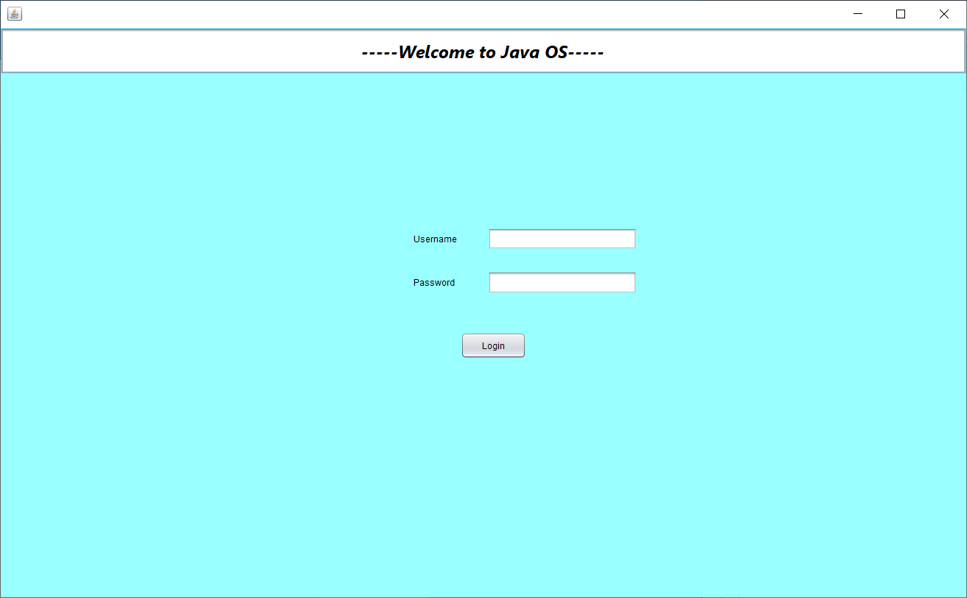

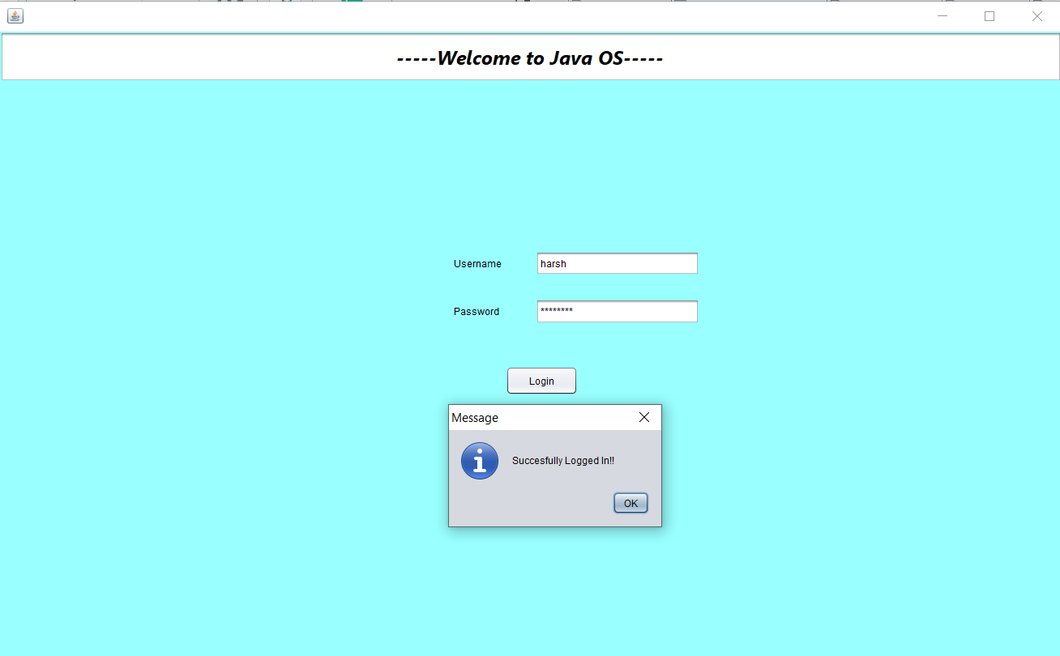

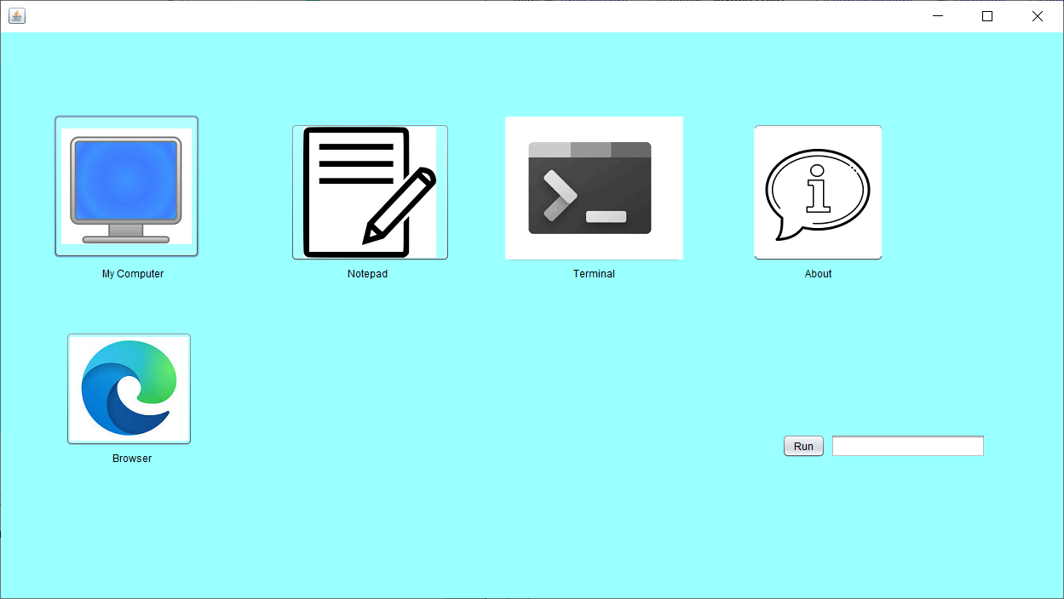

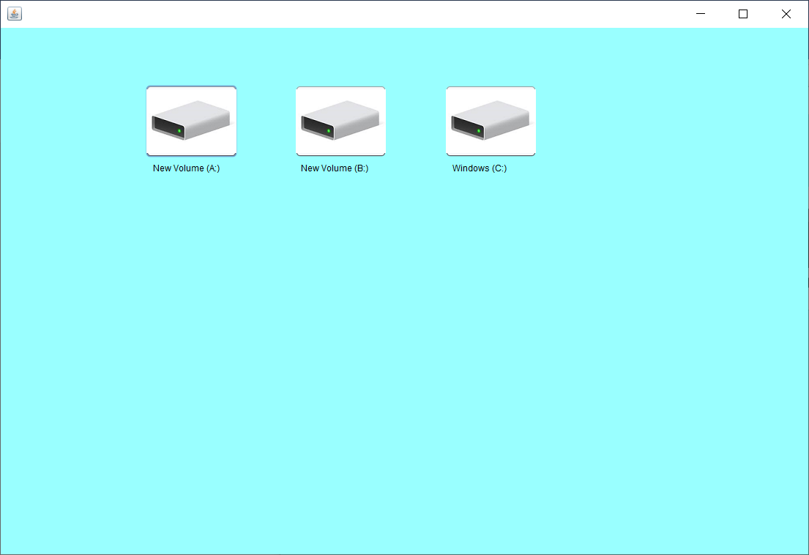

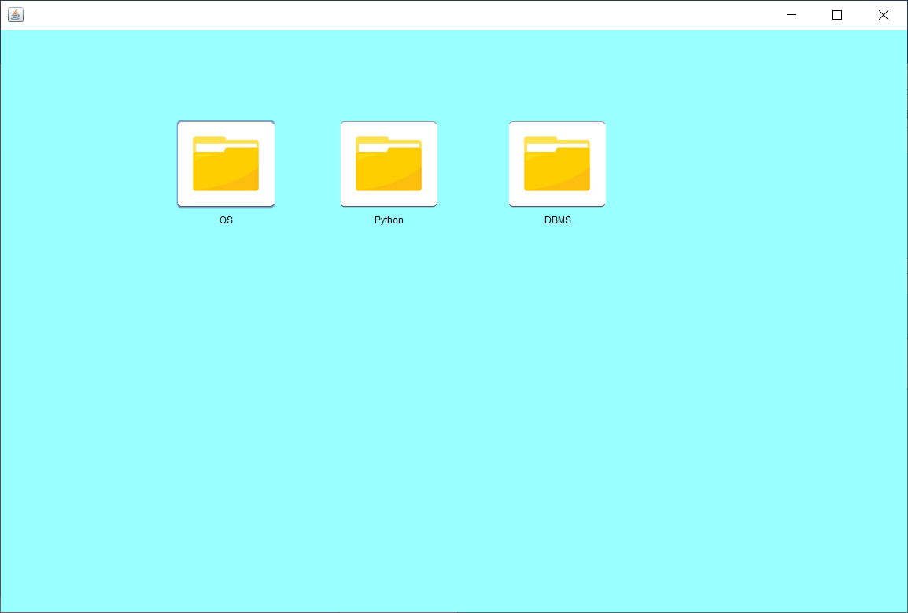

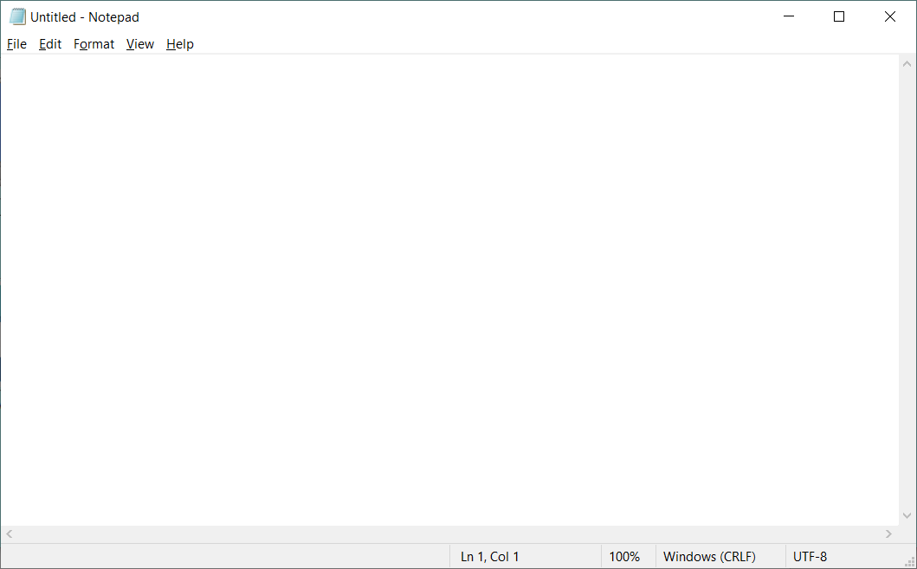

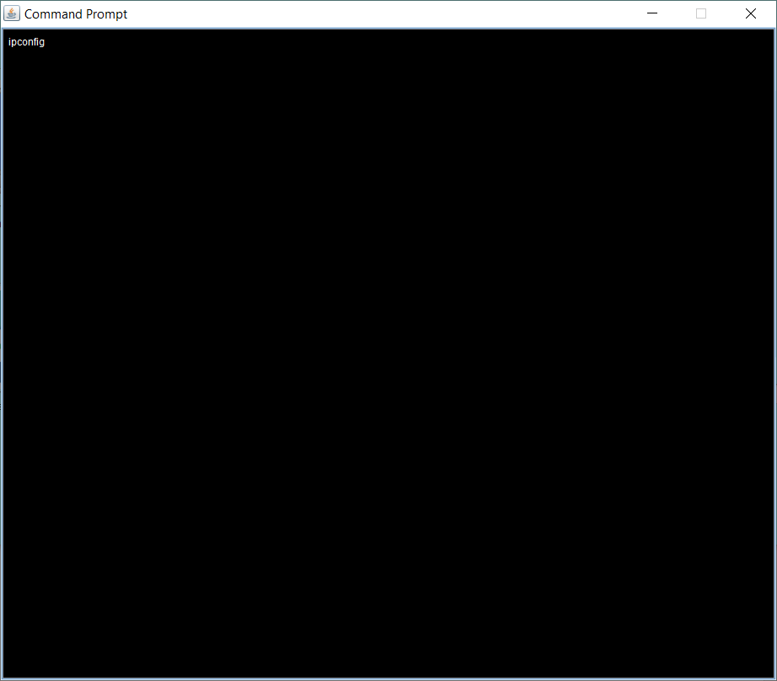

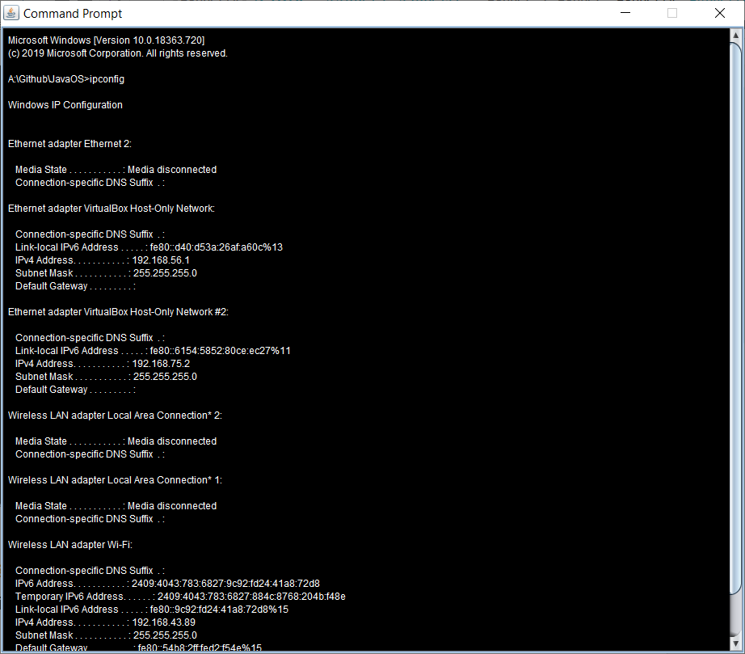

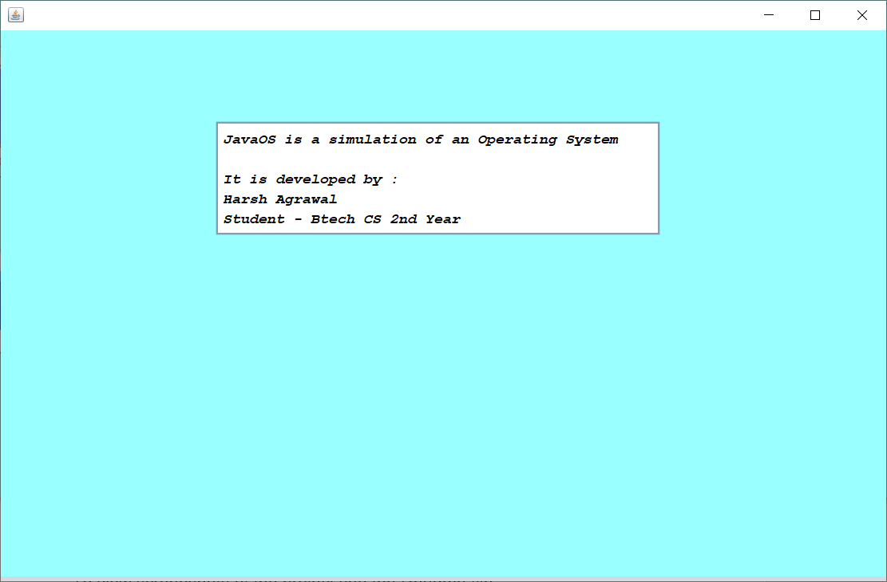

Browser button opens up Microsoft Edge with [www.google.com](http://www.google.com) as default page.

**To View the code and screenshots in more organized manner please visit this github repository -**

<https://github.com/harshag24/JavaOS>

To view screenshots of the project see the Readme file.

**Flowchart –**

1. **FCFS**

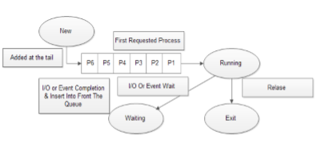

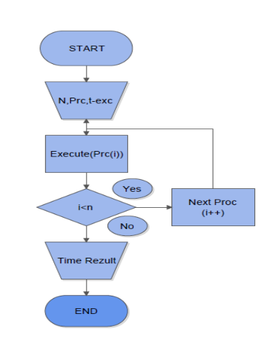

1. **LRU**

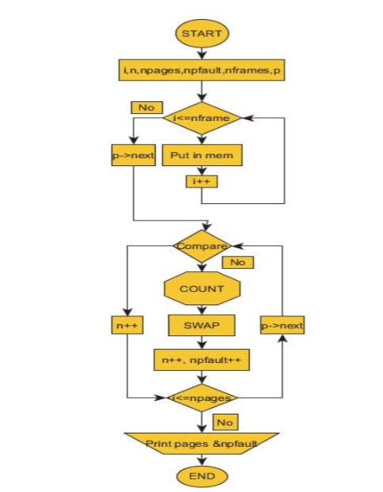

1. **Complete System Flowchart**

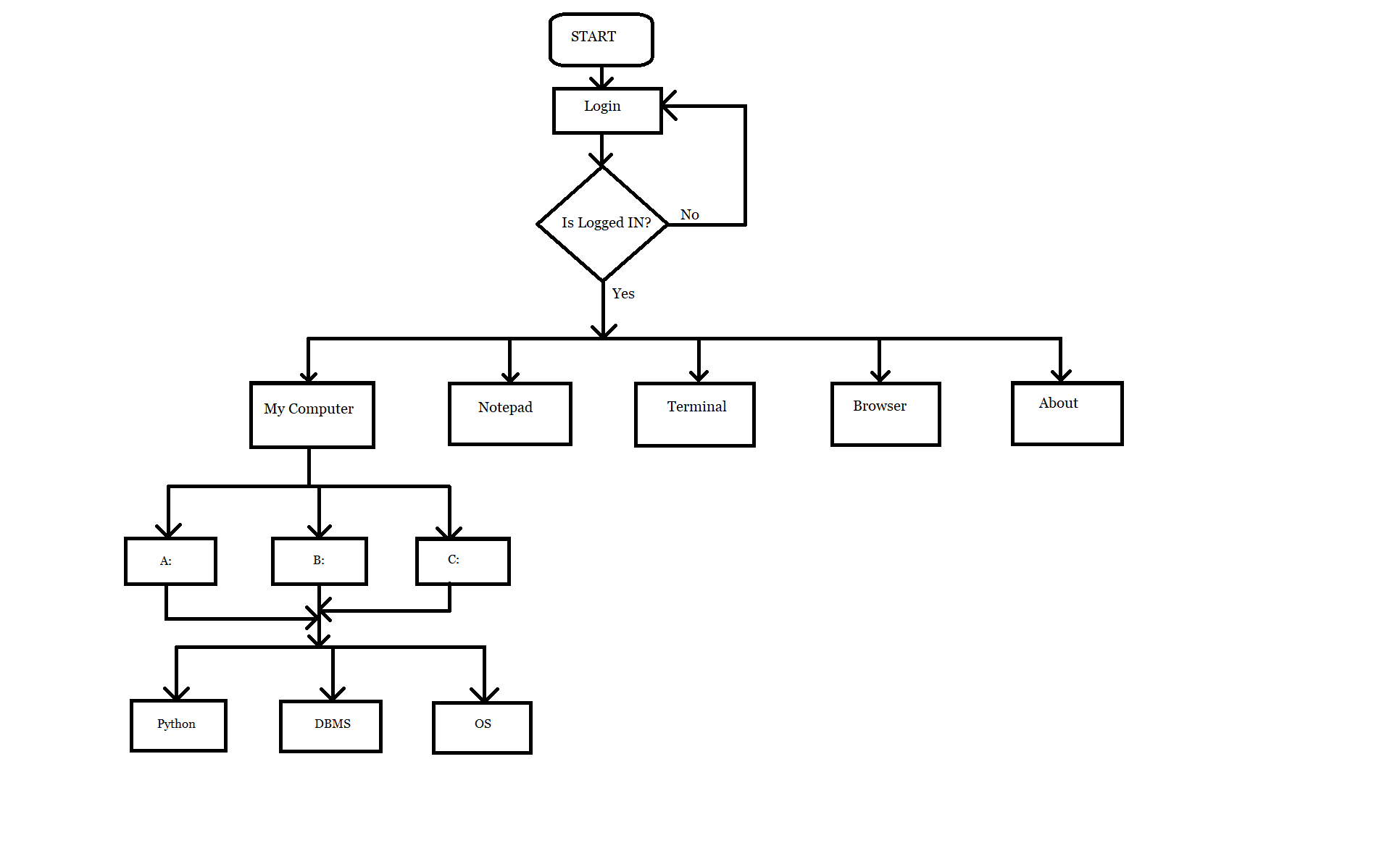

**Limitation and Future scope** –

There are various Limitations , few of them are –

Only limited functionalities of an OS are implemented , only single user access is given , Its not possible to create new files and folders , To access various folders they should be present on the base OS already. Also only one command can be run at a time in terminal , after its completion you have to close it and open terminal once again to run another command.

As it is an simulation direct application is not possible but combining this with hardware and adding various new functionalities can be used to make a new Operating System.

**List of References** –

1. <https://www.javatpoint.com/java-tutorial>
2. <https://www.geeksforgeeks.org/java/>
3. <https://stackoverflow.com/questions/15464111/run-cmd-commands-through-java>
4. <https://www.javaworld.com/article/2077521/java-tip-24--how-to-play-audio-in-applications.html>
5. <https://stackoverflow.com/questions/5226212/how-to-open-the-default-webbrowser-using-java>